Forest Park Primary School Week beginning: Monday 1st June 2020
Nursery Home Learning Record

Weekly Checklist Try to tick off as many of these activities as you can each week as part of your home learning. Please send pictures of any activities you do to nursery@forestpark.org.uk  Reading-Aim for 10 minutes per day. Share a story together and talk about the pictures and characters in the story.  Mon⚪ Tues⚪ Wed⚪ Thurs⚪ Fri ⚪ Maths- Daily number recognition practice: -  Make cards with numbers 0-5 on.  Mix them up and lay them out on the floor. Ask your child to find a number. If your child can do this easily then add numbers up to 10 or 20  Mon⚪ Tues⚪ Wed⚪ Thurs⚪ Fri ⚪  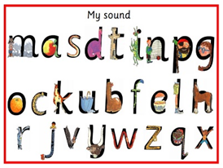  Sound recognition:  Make cards with the  Set 1 sounds on for your  child to look at. Ask your  child to find a sound.  Mon⚪ Tues⚪ Wed⚪ Thurs⚪ Fri ⚪ | Arithmetic Practice  Ordering numbers.  Use your number flash cards. Start with numbers 0-5.  Put them in a muddle on the floor or table. Can you put them in order?  Remember to touch each card and count along the number line to check!  You can play a number ordering game here.  https://www.topmarks.co.uk/ordering-and-sequencing/caterpillar-ordering  start with numbers to 5.  Shape challenge.  Can you find a shape with 4 sides in your house?  What shape is it? Is it a square, rectangle, kite or diamond.  Send a picture of what you have found to  nursery@forestpark.org.uk  by the 10th June. | Topic Review  Exploring the world:  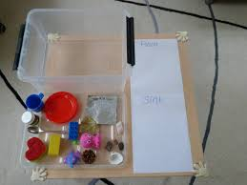  Floating and sinking  Choose 10 objects around the house.  Use a bowl of water. A bath, sink or paddling pool will also work, use what you have.  Have a guess at whether you think each item will sink or float.  Put each item in the water, does it float or sink? Talk about why it might have floated or not.  Please send photos of you completing this activity to Nursery email by Wednesday 10th June.

