Forest Park Primary School Week beginning: Monday 6th July 2020
Year 3 Home Learning Record year3@forestpark.org.uk

Weekly Checklist Try to tick off as many of these activities as you can each week as part of your home learning.  Reading -Aim for 20-30 minutes per day  Mon⚪ Tues⚪ Wed⚪ Thurs⚪ Fri ⚪  Maths- Daily TT Rockstars practice  Mon⚪ Tues⚪ Wed⚪ Thurs⚪ Fri ⚪  Spelling Practice - Can you practice spelling these words? When you think you know them get an adult to test you.  - Complete  - Quarter  - Breath  - Describe  - Different  - Weight  Then, put each of them into a sentence to show that you understand their meaning.  Mon⚪ Tues⚪ Wed⚪ Thurs⚪ Fri ⚪ | Arithmetic Practice  Use the written methods we have learned in school to solve these subtraction sums.  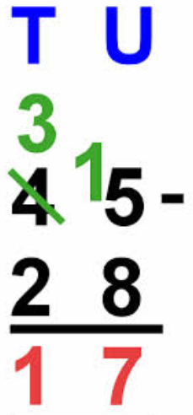  a) 615 - 210 =  b) 596-246 =  c) 789-209 =  d) 536-294 =  e) 785-259 =  f) 562-399 =  g) 564-286 =  h) 900-456 = | Topic Review  This year we have written instructions for ‘How to be a Roman soldier.’ Remember that we introduced each step of the instruction with a time connective, adverb and imperative verb e.g First, carefully chop.  - Watch the video to refresh your memory on how we write instructions.  https://www.bbc.co.uk/bitesize/topics/zkgcwmn/articles/zfrcmfr  - Can you write a set of instructions for making either a healthy wrap or sandwich.  You will get extra kerching for sending us pictures of creations. Yum!  A photo of completed work /task etc must be emailed to year group email by Friday 10th July

