Forest Park Primary School Week beginning: Monday 19th October 2020
Year 3 Home Learning Record

Weekly Checklist Please complete/tick off the activities for the days that you are not in school. A photo of each piece of work will need to be emailed to your teacher by Friday. Email work to: Year3@forestpark.org.uk  Reading:  Log in to Oxford Owl (https://www.oxfordowl.co.uk) using the ‘My Class login’ button:  Username: year3of  Password: year3  Enter ‘My Bookshelf’ and select a book from your current book band to read.  Aim for 20-30 minutes per day  Mon⚪Tues⚪Wed⚪Thurs⚪Fri ⚪  Maths: Daily TT Rockstars practice  Use your login to practise your TT rockstars every day. You will need to practise your x2, x3, x4, x5, x8 and x10 times tables.  Mon⚪Tues⚪Wed⚪ Thurs⚪Fri ⚪  Spelling Practice  Log in to Oxford Owl (https://www.oxfordowl.co.uk) using the ‘My Class login’ button:  Username: year3of  Password: year3  Enter the RWI Spelling Extra Practice Zone and complete the Year 2 Sounds the Same’ activity. | English:  This week we will be beginning to gather ideas for a non-chronological report about a pre-historic animal. Complete one grammar video from below each day and complete any follow up activities.  https://classroom.thenational.academy/lessons/to-identify-features-of-a-non-chronological-report-ctjk8c  https://classroom.thenational.academy/lessons/to-revise-compound-sentences-c4t3jd  https://classroom.thenational.academy/lessons/to-investigate-suffixes-plurals-6nj64c  Thurdsday/Friday  Gather facts about what your animal looks like, diet, habitat and then an additional interesting fact.  Arithmetic:  Use the written methods we have learned in school to solve these calculation problems:  Use the correct symbol, to make the sentences correct  ( < > or = )  4 hundred nine tens and eight ones___ 203  638___ forty tens and seven ones  1000 ___ 999  Eight hundred and seventy one ones___ 971  489___ Five hundred and 15 ones  Seventy five tens __ 751  501 ___ five hundred and ten  17___639  Maths:  The following link will take you to our maths lessons for this week. Make sure you pause the video when instructed to by the teacher and complete any activities.  https://whiterosemaths.com/homelearning/year-3/week-3/  There are two videos for you to view this week:  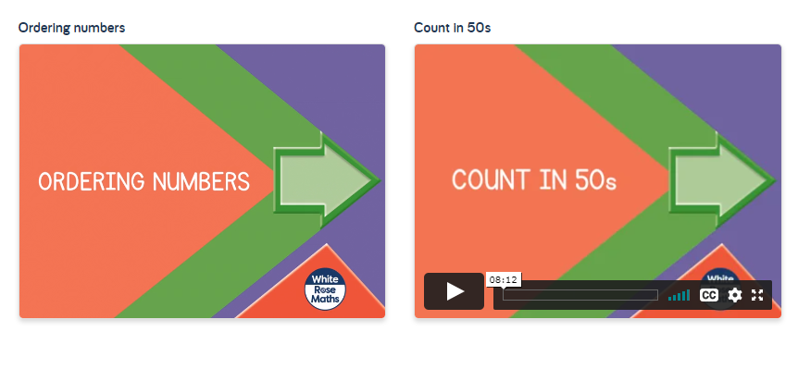 | Topic:  Science:  The following link will take you to our science lesson for this week. Make sure you pause the video when instructed to by the teacher and complete any activities.  - How do plants adapt to different environments?  https://classroom.thenational.academy/lessons/how-do-plants-adapt-to-different-environments-6xj3jr  History:  The following link will take you to our history lesson for this week.  Make sure you pause the video when instructed to by the teacher and complete any activities.  - What are the similarities and differences between the Stone Age periods?  https://classroom.thenational.academy/lessons/what-are-the-similarities-and-differences-between-stone-age-periods-cdhk2d
.

