Forest Park Primary School Week beginning: 19th October 2020
Year 1 Home Learning Record
Weekly Checklist Try to tick off as many of these activities as you can each week as part of your home learning.  Reading  Aim for 10 minutes per day - Free eBook library  Mon⚪ Tues⚪ Wed⚪ Thurs⚪ Fri ⚪  Daily phonics lesson.  Please do this first thing in the morning on each day to ensure the video works. You will need a pencil and paper for the spelling lessons on Tuesday and Thursday.  Mon⚪ Sound ch  Word reading time  Tues⚪ Sound qu  Word reading spelling  Wed⚪ Sound ng  Word reading time  Thurs⚪ Sound nk  Word reading spelling  Fri ⚪Sound th | Arithmetic Practice  Practice writing your numbers forwards and backwards from 10-0.  0, 1, 2, 3, 4, 5, 6, 7, 8, 9, 10  10, 9, 8, 7, 6, 5, 4, 3, 2, 1, 0  Daily Maths- Shape  Mon⚪ Lesson 1  Tues⚪ Lesson 2  Wed⚪ lesson 3  Thurs⚪ lesson 4  Fri ⚪Lesson 5  Spelling Practice - Practice these words everyday. Write each one 5 times.  and  she  have  in  has  Practice writing your name each day.  First name and surname.  Please email your work by 3pm to year1@forestpark.org.uk. | Topic Review  This week we are looking looking at the Artist Keith Haring. Can you use google to find 4 facts about him.  We are learning about primary colours. Can you draw three circles and colour them in with the 3 primary colours.  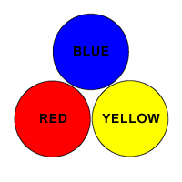  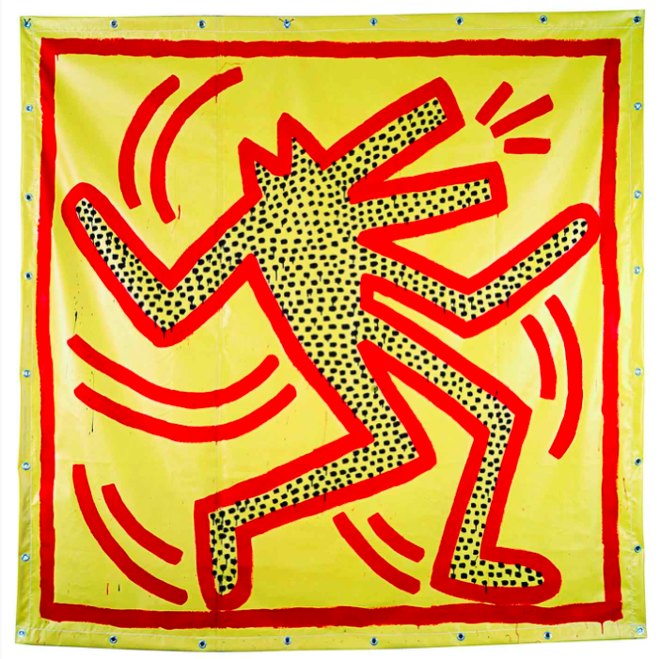  Can you create a picture in the style of Keith Haring using primary colours.  We are reading the book Funny bones. Click to listen to the story.  Here are some songs for you to join in with  Four Seasons Song | Jack Hartmann  Months of the year

