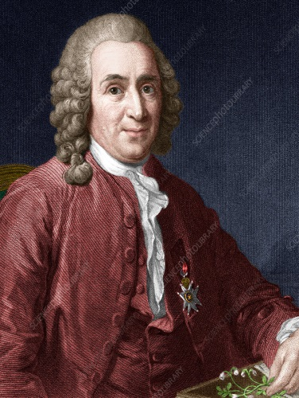
Year 6 Science Knowledge Organiser- Living things and their habitats
Carl Linnaeus
Carl Linnaeus (Carl von Linne), 1707- 1778, Sweden.
Botanist (scientific study of plants), zoologist (study in the classification of animals) and physician (medical professional).
Created the binomial nomenclature system to classify living things (plants and animals).

How to group living things.
A Kingdom is the highest classification into which living organisms are grouped in Linnean taxonom. The five kingdoms in which living things are groups are: Protista, Monera, Fungi, Plants, and Animals.
These groups are then split into smaller groups.

Science Vocabulary Dozen
Micro-organisms | A living thing too small to been seen by the human eye. | Annelids | An invertebrate that is a segmented worm.
Invertebrate | Animals without a backbone. | Arachnid | Small invertebrate usually with 8 legs.
Vertebrate | Animals with a backbone or spinal column. | Species | A group of living things that are closely related.
Arthropod | An invertebrate with an exoskeleton an a segmented body. | Bacteria | A single celled micro-organism that can live anywhere.
Insect | A small arthropod animal that has six legs and three body parts. | Deciduous | Plants that shed their leaves annually.
Molluscs | Invertebrate with an unsegmented body that can have a hard shell. | Coniferous | Evergreen plants usually with needle-shaped or scale-like leaves, pines or cones.
Animal Kingdom
Animals can be classified in 2 main groups and then sub-divided further.
Invertebrates  Animals without a backbone. | Annelida worms-earthworms, leech | Vertebrates  Animals with a backbone. (chordata) | Bird-  penguin, owl, ostrich, robin
 | Arthropods-spiders, ant, butterfly, centipede, crustacean-crab |  | Fish-  tuna, shark, pike, pufferfish
 | Molluscs-Snail, squid, octopus, oysters |  | Mammal-  bat, dolphin, whale, humans
 | Flatworm- moon flatworm, tape worm |  | Reptile-  snake, crocodile, turtles, geckos
 | Echinodermata- starfish, sea urchin, sand dollars |  | Amphibian-  toad, salamander, frog, newt
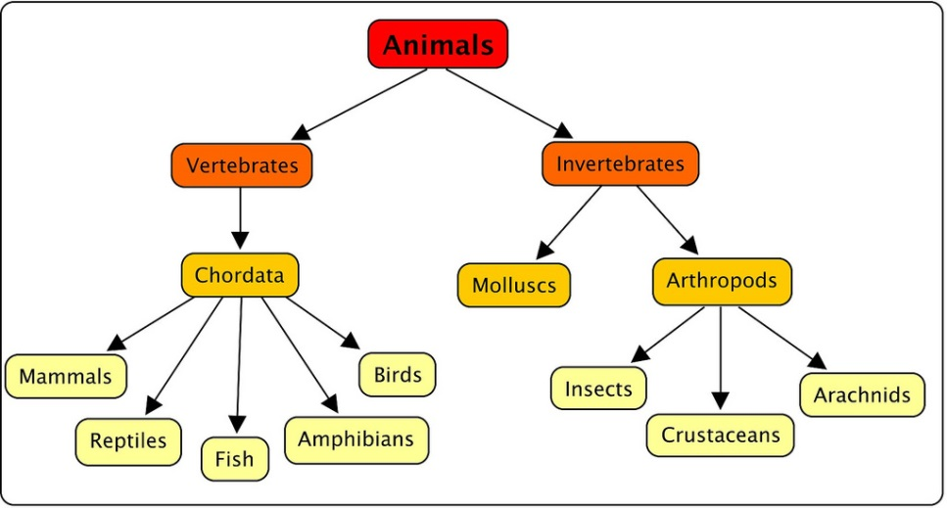
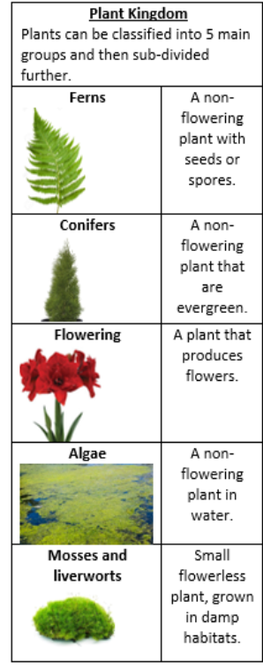
Branching database- used to classify groups.

