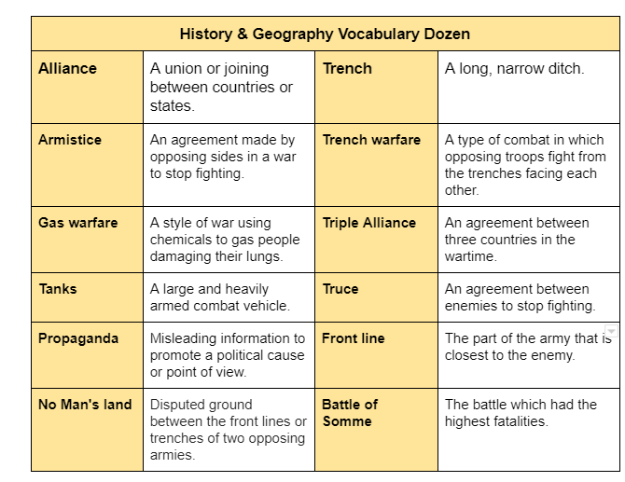
Year 6 History & Geography Knowledge Organiser - World War One
Poppies became a symbol of World War I because they have grown around some of the places where battles were fought
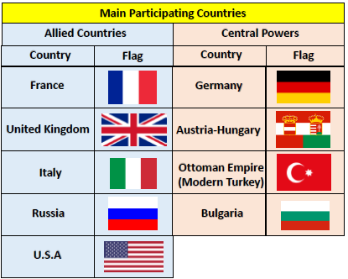
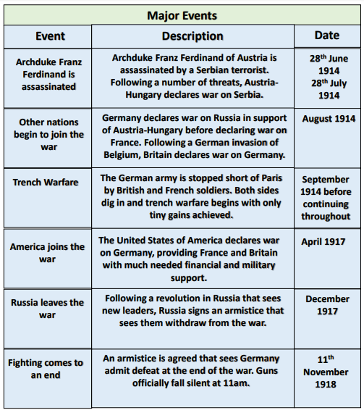
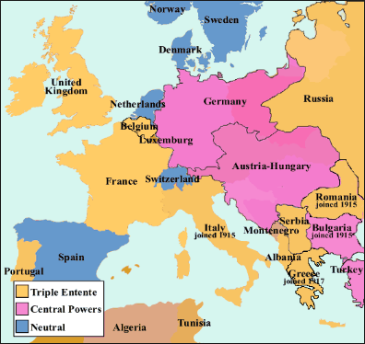
Many people wear a red poppy in honour of Remembrance Day - Remembrance Day is always the 11th of November.

