Forest Park Primary School Week beginning: Monday 28th September 2020
Year 5 Home Learning Record

Weekly Checklist Try to tick off as many of these activities as you can each week as part of your home learning.  Reading  Log in to Oxford Owl (https://www.oxfordowl.co.uk) using the ‘My Class login’ button:  Username: year5ds  Password: dragonflies  Enter ‘My Bookshelf’ and select a book from your current book band to read.  Aim for 20-30 minutes per day  Mon⚪ Tues⚪ Wed⚪ Thurs⚪ Fri ⚪  Maths  Daily TT Rockstars practice  Mon⚪ Tues⚪ Wed⚪ Thurs⚪ Fri ⚪  Arithmetic Practice  Use the written methods we have learned in school to solve these calculation problems:  a) 3 x ? = 87  b) 90 divided by 5  c) 560 divided by 8  d) 7 + 5 + ? = 15  e) ? = 20 -14  f) ? + 9 = 15  g) ¾ of 12  h) ¼ of 20 | Maths  Watch the following videos, one per day, pausing when told to complete the tasks on paper.  Rounding 5 digit numbers:  https://classroom.thenational.academy/lessons/rounding-5-digit-numbers-to-the-nearest-10-000-and-1000-chgk2r  Rounding 5 digit numbers (next lesson):  https://classroom.thenational.academy/lessons/rounding-5-digit-numbers-to-the-nearest-100-1000-and-10-000-6hgk2d  Identifying place value in 6 digit numbers:  https://classroom.thenational.academy/lessons/identifying-the-place-value-of-the-digits-in-6-digit-numbers-6hh62c  Spelling Practice  Log in to Oxford Owl (https://www.oxfordowl.co.uk) using the ‘My Class login’ button:  Username: year5ds  Password: dragonflies  Enter the RWI Spelling Extra Practice Zone and complete the Year 5 ‘Swap, Double or Drop’ activity.  Writing  https://www.youtube.com/watch?v=6KSiyaqnZYs  Write an informal letter from Dorothy to Aunt Em and Uncle Henry from the Land of Oz describing what Dorothy and Toto have discovered. Include setting information and their feelings.  Grammar  https://classroom.thenational.academy/lessons/to-explore-expanded-noun-phrases-64r3ec  Watch this video, pausing when told to complete the tasks on paper. | Topic  History  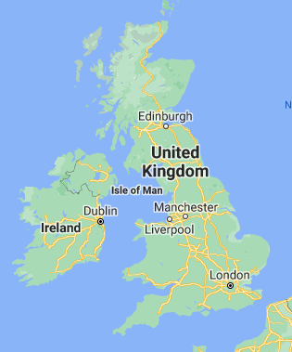  Use Google maps (www.google.co.uk/maps) to find and mark the following cities on a blank map of the United Kingdom:  Birmingham, Manchester, Liverpool, Sheffield, Leeds, Stoke-on-Trent, Bradford, Newcastle, Glasgow, Edinburgh, Cardiff, Derby, Bristol and London.  Then find and mark on the River Trent, River Mersey, River Severn and the River Thames.  Why do you think the location of these cities and these rivers were important during the Industrial Revolution?  CHALLENGE: What are the advantages and disadvantages with using rivers as a method of transport?  Science  Use your science KO Life Cycles and Plants (on the school website or your printed copy to revise the vocabulary dozen). Ask someone to read the word to you and try to give them an accurate definition.  Read the information on the life cycle of a butterfly.  https://www.natgeokids.com/uk/discover/animals/insects/butterfly-life-cycle/  Make your own life cycle of a butterfly. Use diagrams and labels.

