Forest Park Primary School Week beginning: Monday 21st September 2020
Year 5 Home Learning Record

Weekly Checklist Try to tick off as many of these activities as you can each week as part of your home learning.  Reading  Log in to Oxford Owl (https://www.oxfordowl.co.uk) using the ‘My Class login’ button:  Username: year5ds  Password: dragonflies  Enter ‘My Bookshelf’ and select a book from your current book band to read.  Aim for 20-30 minutes per day  Mon⚪ Tues⚪ Wed⚪ Thurs⚪ Fri ⚪  Maths  Daily TT Rockstars practice  Mon⚪ Tues⚪ Wed⚪ Thurs⚪ Fri ⚪  Arithmetic Practice  Use the written methods we have learned in school to solve these calculation problems:  a) 29 + 52 =  b) 65 - 28 =  c) 6 x 8 =  d) 1/7 + 4/7 =  e) 17 x 3 =  f) 48 +63 =  g) 28 x 4 =  h) ¾ of 8 = | Maths  Watch the following videos, one per day, pausing when told to complete the tasks on paper.  Identifying Place Value in 5 digit numbers  https://classroom.thenational.academy/lessons/identifying-the-place-value-of-digits-in-5-digit-numbers-cgwkct  Comparing 5 digit numbers  https://classroom.thenational.academy/lessons/comparing-5-digit-numbers-cnhk6c  Using a numberline  https://classroom.thenational.academy/lessons/ordering-and-comparing-5-digit-numbers-using-a-number-line-c4r62c  Spelling Practice  Log in to Oxford Owl (https://www.oxfordowl.co.uk) using the ‘My Class login’ button:  Username: year5ds  Password: dragonflies  Enter the RWI Spelling Extra Practice Zone and complete the Year 5 ‘Sounds the Same’ activity.  Writing  https://www.youtube.com/watch?v=RQWSh7Db-_E  Watch the video of Dorothy and the tornado, then write a postcard to Uncle Henry and Aunt Em as if you were Dorothy in the middle of the tornado.  Grammar  https://classroom.thenational.academy/lessons/to-explore-the-functions-of-fronted-adverbials-6dhpcc/activities/1  Watch this video, pausing when told to complete the tasks on paper. | Topic  History  This week we are exploring the causes of the Industrial Revolution. Watch https://www.youtube.com/watch?v=4As0e4de-rI Watch from 19:20min to 25:50min.  What is happening here?  How does the video show how Britain changed during the Industrial Revolution?  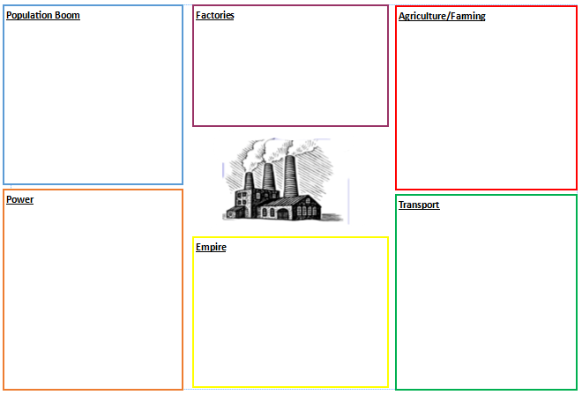  Read the Powerpoint about six of the causes of the Industrial Revolution, then complete the chart in your own words. (These resources will be emailed to you separately.)  In your opinion, what was the most significant cause of the Industrial Revolution? Why?  Science  Use your science KO Life Cycles and Plants (on the school website or your printed copy to revise the vocabulary dozen). Ask someone to read the definitions to you and try to give them the correct word to match.  Watch ‘The life cycle of an animal’  https://www.bbc.co.uk/bitesize/clips/zt96sg8  Use the KO to make your own life cycle of a frog. Use diagrams and labels.
(

