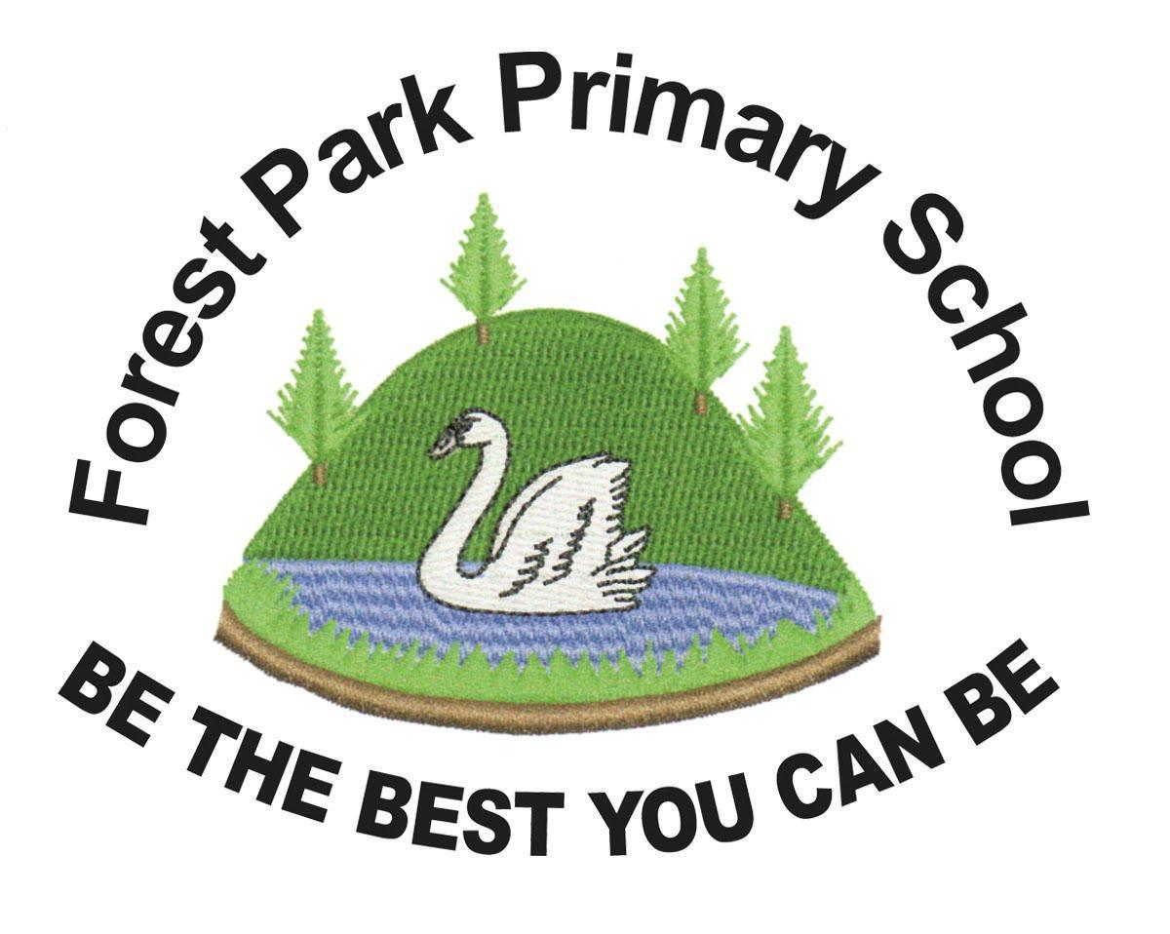
Forest Park Primary School Week beginning: Monday 28th September 2020
Year 4 Home Learning Record year4@forestpark.org.uk

Weekly Checklist Try to tick off as many of these activities as you can each week as part of your home learning.  Reading -Aim for 20-30 minutes per day  Mon⚪ Tues⚪ Wed⚪ Thurs⚪ Fri ⚪  Maths- Daily TT Rockstars practice  Mon⚪ Tues⚪ Wed⚪ Thurs⚪ Fri ⚪  Spelling Practice -  Our spelling rules for this week is -sure. It can be used to create a root word such as measure.It can also be used with a suffix such as measurement.  Write down 5 words that you can think of which have -sure in. Be careful, as measuring drops the ‘e’ when adding -ing. Then put these into a sentence.  Mon⚪ Tues⚪ Wed⚪ Thurs⚪ Fri ⚪ | Arithmetic Practice  Work out what is 1000 more and 1000 less for each number. Think, which is the only column that needs to change?  a) 4000  b) 5400  c) 6210  d) 8129  e) 2014  f) 1902  g) 9210  h) 3913  i) 8319  j) 1931  Maths Practice  What is place value?  https://www.bbc.co.uk/bitesize/topics/zsjqtfr/articles/z9w3g82  Click on the link and watch the video which explains place value up to 10,000. Then, have a go at the 3 questions underneath by dragging the correct numbers into the boxes. Finally, take the place value quiz at the bottom of the page. Don’t forget to send us your score in your email. | Topic Review  Science  In Science this term we are looking at what impacts humans have on the environment. Click on the link below to watch and read about this. Then take the quiz.  https://www.bbc.co.uk/bitesize/topics/zp22pv4/articles/z2md82p  Task- Using everything that you have learnt, create a poster about what positive and negative impacts humans have on the environment. Make this eye-catching to encourage humans to look after our environment. Make sure you send these to us as we would love to put them on display!  History  In History this term, we are looking at the Anglo-Saxons and Vikings. Use the link below to find out what jobs the Anglo-Saxons had.  https://www.bbc.co.uk/bitesize/topics/zxsbcdm/articles/zq2m6sg  Using your knowledge from this, answer:  - What jobs did Anglo-Saxon girls have?  - What jobs did Anglo-Saxon boys have?  - What jobs did Anglo-Saxon men have?  - What jobs did Anglo-Saxon women have?  Aim to write at least 3 for each one!

