Year 4 Science Knowledge Organiser: Animals including humans
Vertebrates - An animal with a backbone, including: mammals, birds, reptiles, amphibians and fish.
Invertebrates - An animal without a backbone, such as insects, molluscs, annelids and arachnids. | 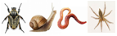

Vocabulary Dozen
Classification | The arrangement of animals and plants in groups according to their observed similarities. | Non-flowering | A type of green plant that has very small leaves and no flowers and that grows on rocks, bark, or wet ground.
Characteristics | A feature or quality belonging typically to a person, place, or thing and serving to identify them. | Classify | Arrange (a group of people or things) in classes or categories according to shared qualities or characteristics.
Habitat | The natural home or environment of an animal, plant, or other organism. | Environment | The surroundings or conditions in which a person, animal, or plant lives.
Positive | A desirable quality or attribute. | Impact | A marked effect or influence.
Vertebrate | An animal or a large group of animals distinguished by the possession of a backbone or spinal column. | Negative | An undesirable quality or attribute.
Flowering | A plant (such as a grass) that produces grain that can be eaten. | Invertebrate | An animal lacking a backbone.

Flowering plants |  | Non-flowering plants
Dandelion |  | Fern | 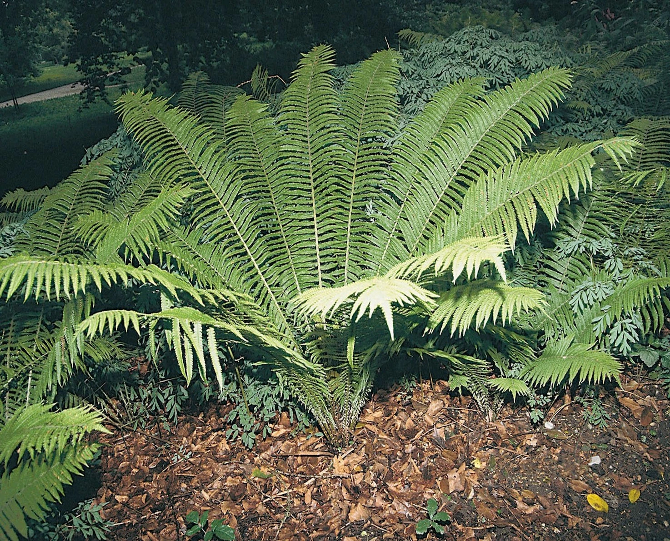
Daffodil |  | Conifers | 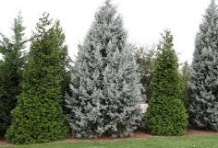
Tomato Plant | 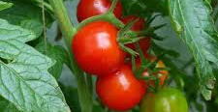 | Moss | 