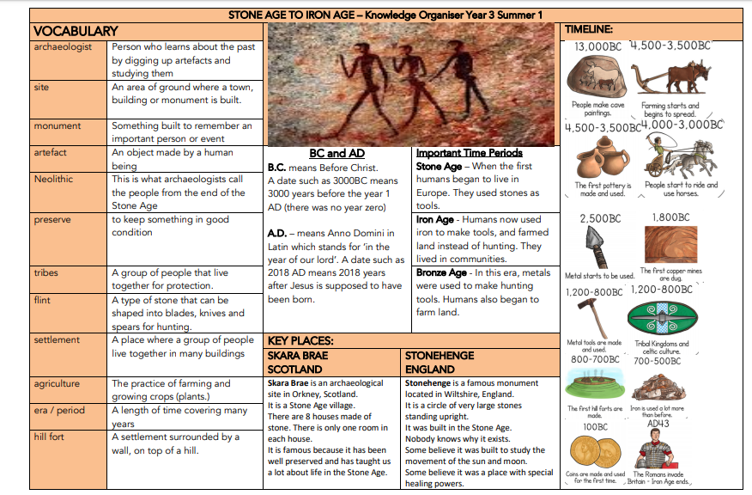

Stone Age to Iron Age – Knowledge Organiser Year 3 Autumn 1 and 2

Pre-history | The period of time before written records
Round house | A circular house with a straw roof.
Hill fort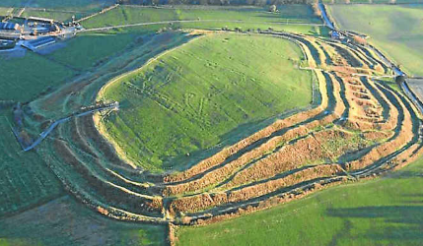 | Elevated ground that provided an excellent view to provide defence.
