Science Focus: | Plants |  | Year 2 |  | Autumn 1st Half Term
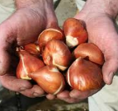
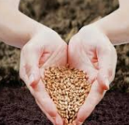
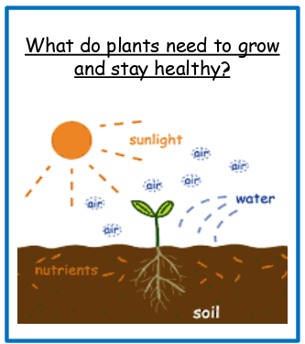
Bulbs can grow into a new plant every year.
Seeds only grow into a new plant once.
Vocabulary Dozen
Spelling | Definition
plant | A living thing that usually grows from the ground or soil.
seed | Grows into a new plant by reproduction.
bulb | A think rounded part of a plant from which a stem and roots grow.
trunk | The main stem of a tree from which its branches and roots grow.
grow | Increasing in size and changing physically in a natural way.
growth | Growth in plants occurs as the stems and root get longer.
healthy | Healthy means that something is in a good physical condition free from disease.
survival | Staying alive, not dying.
conditions | The conditions that a plant is kept can affect how healthy that plant will be.
temperature | How hot or cold an object or person is.
mature | When a plant is fully grown, we can say that it is mature or old.

Characteristics of plants
Healthy plant | Unhealthy plant
- Strong green leaves  - Strong stem  - Thick roots | - Droopy or yellow leaves  - Thin weak stem  - Long thin roots
