Focus: Geography | Topic: Landmarks |  | Year 2 |  | Autumn 1st half term
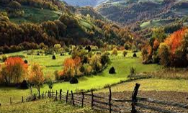
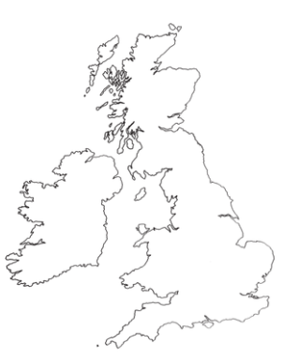
Stoke-on-Trent is located in England, in the West Midlands.
A rural area is the countryside. There are lots of trees, fields, hills and farms. There are not many houses, shops or other buildings.
Stoke-on-Trent
England
Scotland
Northern Ireland
Wales
Vocabulary Dozen
Spelling | Definition
Human feature | Features of an area that a human has built or put there e.g. roads, houses or bus stops.
City | A city is larger than a town.  It is where people live and work.
Town | A town is smaller than a city.  People live and work here too, but it is surrounded by a rural area.
Field | An area of open land, often planted with crops (food), surrounded by a hedge or fence.
Physical feature | Features of an area that are natural. A human did not build these e.g. rivers, hills and mountains.
Forest | A large area covered mainly with trees and undergrowth.
Hill | A naturally raised area of land, not as high as a mountain.
Mountain | A large natural raised area, rising steeply from the surrounding area.
River | A large natural stream of water flowing into the sea, a lake or another river.
Rural | A characteristic of the countryside.
Urban | A characteristic of a town or city.
Landmark | An object or feature of an area that is easily seen or recognised from a distance.
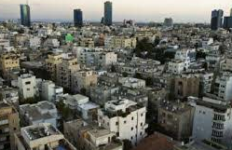
An urban area is a town or city. There are lots of houses, shops and other buildings. There are not as many trees, fields or hills.
Landmarks in Stoke-on-Trent
Physical | Human
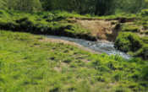  Whitfield Valley  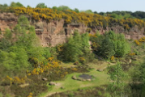  Park Hall  Westport Lake  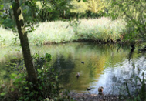 | 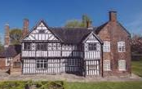  Ford Green Hall  Sir Stanley Matthew statue  Pit Head Wheel Forest Park  