Forest Park Primary School Week beginning: 28th September 2020
Year 1 Home Learning Record
Weekly Checklist Try to tick off as many of these activities as you can each week as part of your home learning.  Reading  Aim for 10 minutes per day - Free eBook library  Mon⚪ Tues⚪ Wed⚪ Thurs⚪ Fri ⚪  Daily phonics lesson.  Please do this first thing in the morning on each day to ensure the video works. You will need a pencil and paper for the spelling lessons on Tuesday and Thursday.  Mon⚪ Sound w  Word reading time  Tues⚪ Sound z  Word reading spelling  Wed⚪ Sound x  Word reading time  Thurs⚪ Sound sh  Word reading spelling  Fri ⚪Sound th | Arithmetic Practice  Practice writing your numbers correctly from 0-10.  1, 2, 3, 4, 5, 6, 7, 8, 9, 10  Daily Maths- Numbers to 10  Mon⚪ Lesson 1  Tues⚪ Lesson 2  Wed⚪ lesson 3  Thurs⚪ lesson 4  Fri ⚪Lesson 5  Spelling Practice - Practice these words everyday. Write each one 5 times.  she  the  had  we  to  Practice writing your name each day.  First name and surname. | Topic Review  This week we are looking at seasons.  We are reading the story of Leaf man.  Watch it here- Leaf man  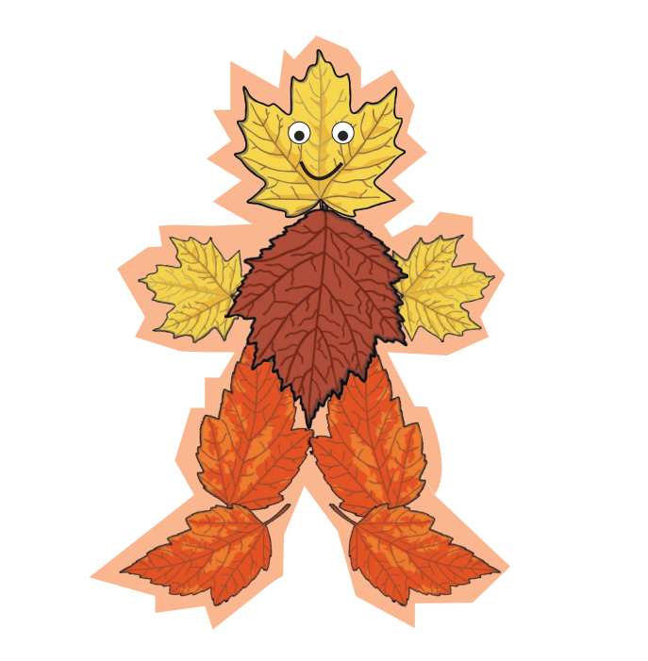  Can you draw 5 things that the Leaf man saw on his Journey?  If you have leaves in your garden you could always create your own Leaf Man.  Watch the video about Autumn.  Can you draw and label 5 things that happen when it’s Autumn.  Here are some songs for you to join in with  Four Seasons Song | Jack Hartmann  Please email your work by 3pm to year1@forestpark.org.uk.

