Forest Park Primary School Week beginning: Monday 1st June 2020
Reception Home Learning Record

Weekly Checklist Try to tick off as many of these activities as you can each week as part of your home learning.  Reading  Aim for 10 minutes per day. Read your favourite story or access ‘Oxford Owl’ website for free eBooks.  Mon ⚪ Tues ⚪ Wed ⚪ Thurs ⚪ Fri ⚪  Maths  Daily counting forwards and backwards to 20  Mon ⚪ Tues ⚪ Wed ⚪ Thurs ⚪ Fri ⚪  RWI  Daily practise of RWI sounds:  Phonics lessons can be found online daily at 9.30am.  https://www.ruthmiskin.com/en/find-out-more/parents/  Mon ⚪ Tues ⚪ Wed ⚪ Thurs ⚪ Fri ⚪ | One Less  Can you find one less than a number? Use the number to find one more of each number up to 10.  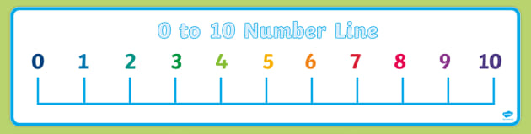  Can you find one less up to 20?  One less than 6 is ……  One less than 2 is …...  Useful Links  Check out the new Numberblocks channel:  https://www.youtube.com/channel/UCPlwvN0w4qFSP1FllALB92w  Check out the new Alphablocks channel:  https://www.youtube.com/channel/UC_qs3c0ehDvZkbiEbOj6Drg | Topic  This week’s topic is On Safari. We will be looking at the story I went to the Zoopermarket. You can watch it here:  https://www.youtube.com/watch?v=akU1-FvsiOg  After you have watched the story, can you write a description of a safari animal but don’t say what it is.  Mrs Dumigan and Miss. Dono would like to read your descriptions and we will guess what animal you have wrote about.  Please send pictures of the activities you do to:  buttercups@forestpark.org.uk  clovers@forestpark.org.uk

