Forest Park Primary School Week beginning: Monday 6th July 2020
Reception Home Learning Record

Weekly Checklist Try to tick off as many of these activities as you can each week as part of your home learning.  Reading  Aim for 10 minutes per day. Read your favourite story or access ‘Oxford Owl’ website for free eBooks.  Mon ⚪ Tues ⚪ Wed ⚪ Thurs ⚪ Fri ⚪  Maths  Can you say your 2 times table to an adult?  You can use a number line or number square to help you.  Mon ⚪ Tues ⚪ Wed ⚪ Thurs ⚪ Fri ⚪  RWI  Daily practice of Set 2 sounds:  Phonics lessons can be found online daily at:  https://www.ruthmiskin.com/en/find-out-more/parents/  Mon ⚪ Tues ⚪ Wed ⚪ Thurs ⚪ Fri ⚪ | Size ordering  Can you sort objects according to their size?  Can you find objects in your house like bowls, teddy bears and cups and put them in size order?  Useful Links  Check out the new Numberblocks channel:  https://www.youtube.com/channel/UCPlwvN0w4qFSP1FllALB92w  Check out the new Alphablocks channel:  https://www.youtube.com/channel/UC_qs3c0ehDvZkbiEbOj6Drg | Topic  This week’s topic is ‘If you go down to the woods today’. We will be looking at the story ‘Goldilocks and the Three Bears.’ You can watch it here:  https://www.youtube.com/watch?v=4JUk4umsUNw  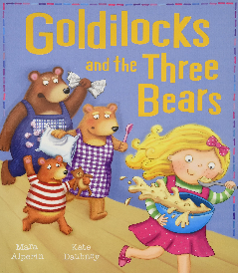  After you have watched the story, can you make a bowl of porridge? How do you like your porridge?  Please send photographs of the activities you do to:  buttercups@forestpark.org.uk – Miss Dono  clovers@forestpark.org.uk –Mrs Dumigan

