Forest Park Primary School Week beginning: Monday 21st September 2020
Reception Home Learning Record

Weekly Checklist Try to tick off as many of these activities as you can each week as part of your home learning.  Reading  Aim for 10 minutes per day. Read your favourite story or access ‘Oxford Owl’ website for free eBooks.  Mon ⚪ Tues ⚪ Wed ⚪ Thurs ⚪ Fri ⚪  Maths  Can you count to 20?  1,2,3,4,5,6,7,8,9,10,11,12,13,14,15,16,17,18,19, 20  Mon ⚪ Tues ⚪ Wed ⚪ Thurs ⚪ Fri ⚪  Phonics  Please watch alphablocks:  M: https://www.bbc.co.uk/cbeebies/watch/alphablocks-man  S: https://www.bbc.co.uk/cbeebies/watch/alphablocks-the-cat-sat-on-the-mat  Mon ⚪ Tues ⚪ Wed ⚪ Thurs ⚪ Fri ⚪ | Matching and Sorting  Can you match the socks in your house?  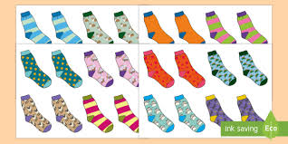  Can you group objects in your house and describe why they are the same?  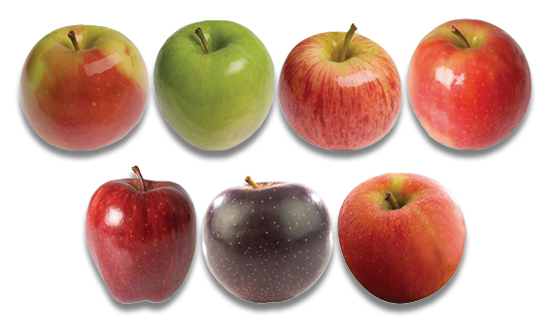  Useful Links  Check out the new Numberblocks channel:  https://www.youtube.com/channel/UCPlwvN0w4qFSP1FllALB92w  Check out the new Alphablocks channel:  https://www.youtube.com/channel/UC_qs3c0ehDvZkbiEbOj6Drg | Topic  Our topic is ‘Colours’. We will be looking at the story ‘The Colour Monster’. You can watch it here: https://www.youtube.com/watch?v=Ih0iu80u04Y  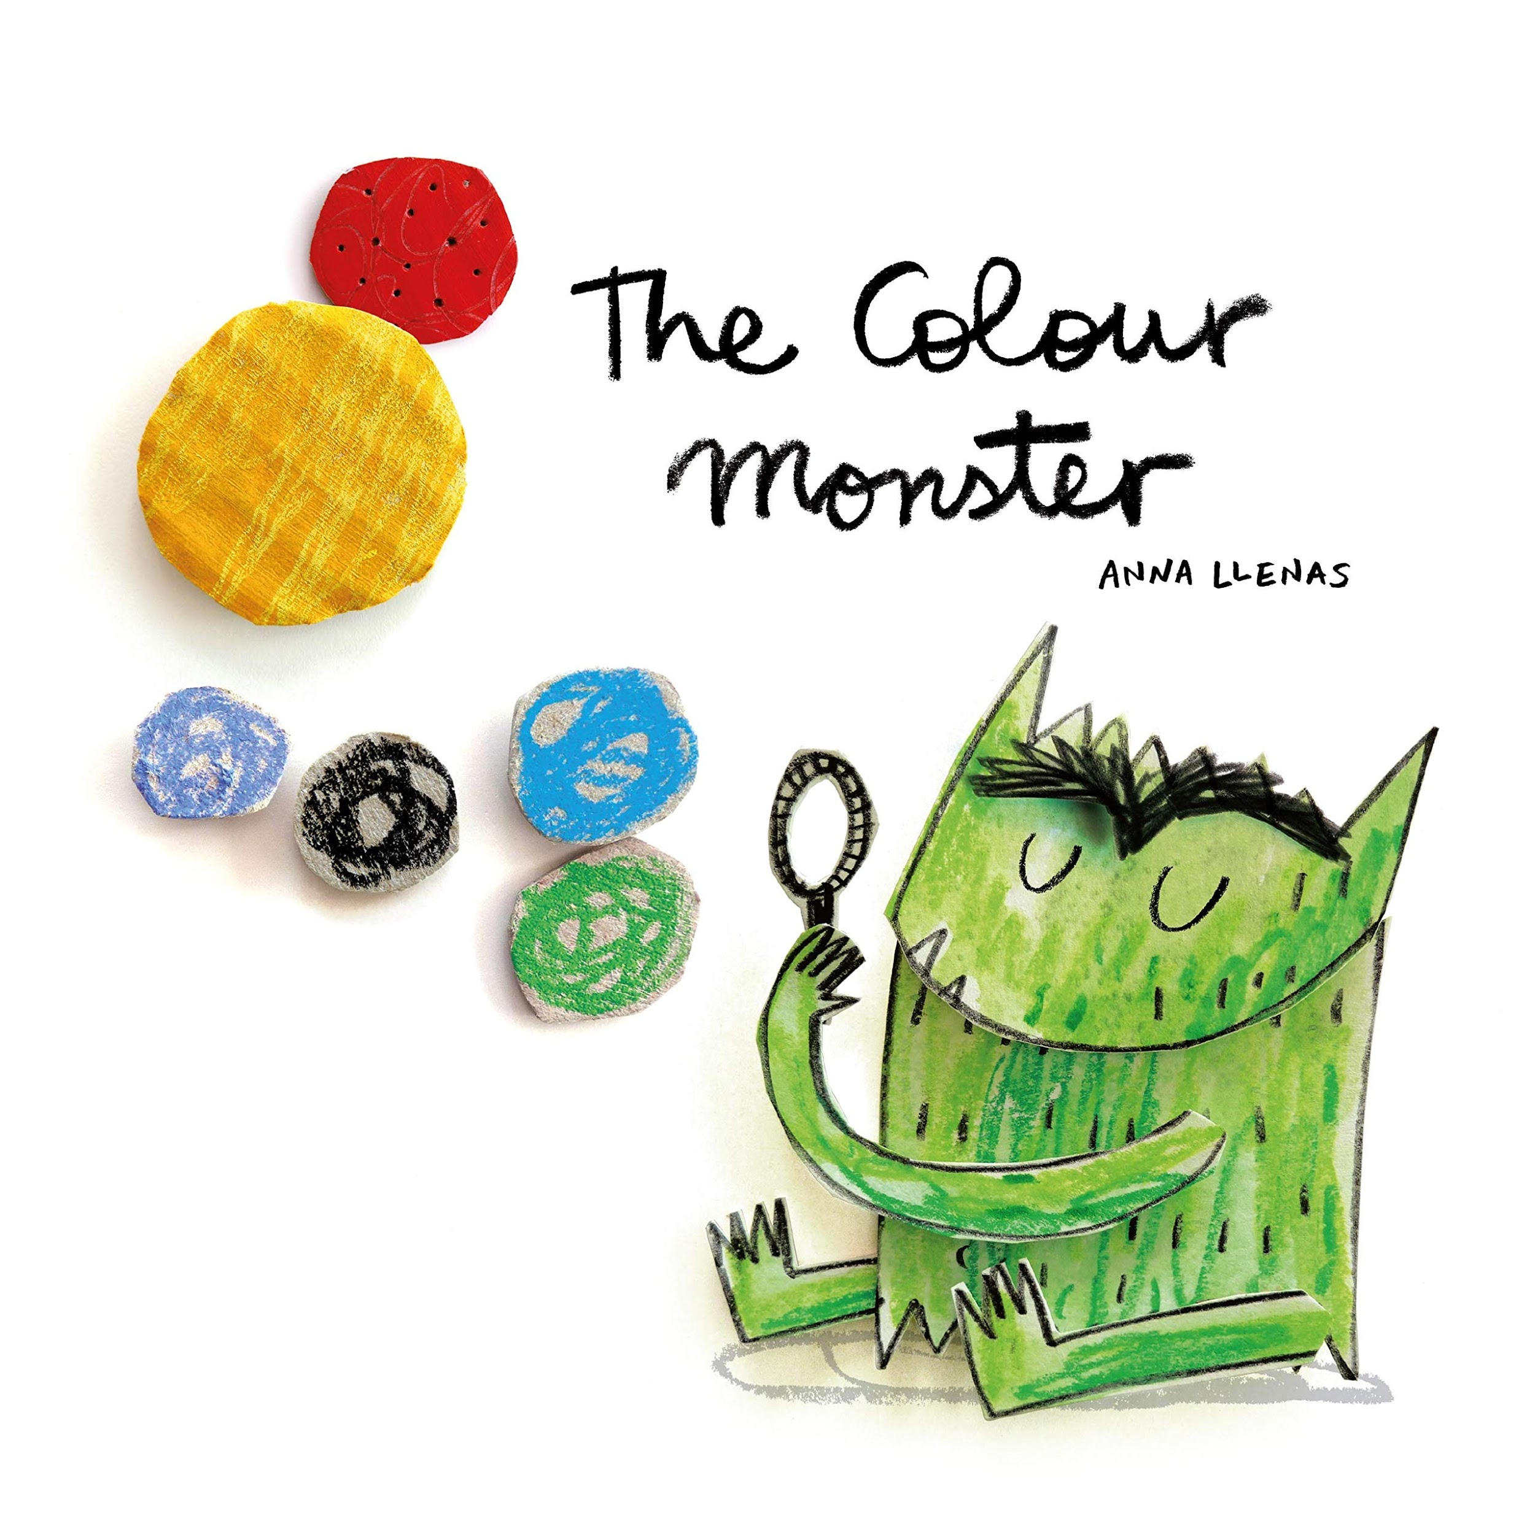  After you have watched the story, can you draw a jar for each of the colours and add objects to the happy jar, sad jar, angry jar, scared jar, calm jar and loved jar.  Please send photographs of the activities you do to:  buttercups@forestpark.org.uk – Miss Dono  clovers@forestpark.org.uk –Miss Swindail and Mrs Bramfitt  Have a great week!

