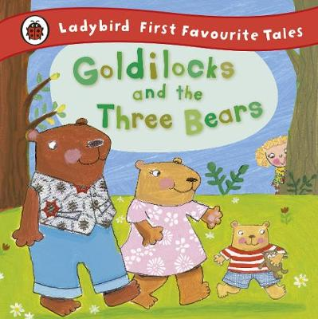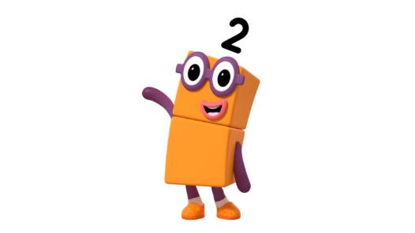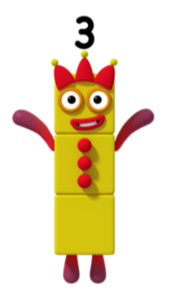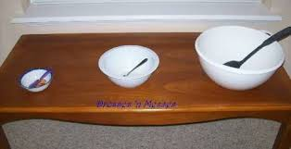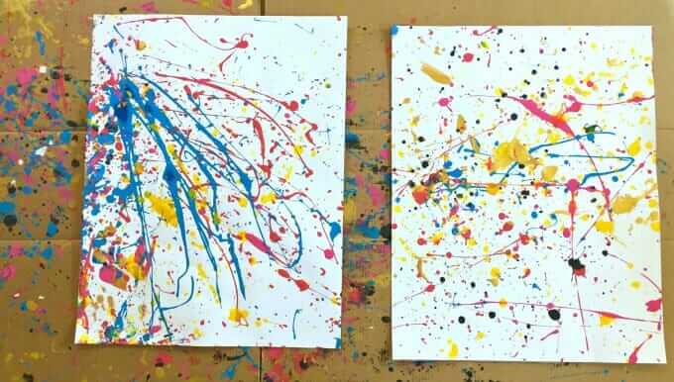

Nursery Rhymes - We have been learning some nursery rhymes and would like your child to practise them at home.

Incy Wincy Spider – https://www.youtube.com/watch?v=YAJynCIsNUg

Head, shoulders, knees and toes – https://www.youtube.com/watch?v=fvEtwhui1k0

I’m a little teapot - https://www.youtube.com/watch?v=mdu5lLpMH_w

Literacy

This half term we are reading the story Goldilocks and the Three Bears.

Please read this book at home with your child. Can they remember what happens next?

There are videos on Youtube of this story e.g.

<https://www.youtube.com/watch?v=qOJ_A5tgBKM>

Can your child act out this story using teddy bears?

Can they tell you about the story? Which part was their favourite?

Goldilocks and the Three Bears - maths

Can your child order 3 objects by size? Please use the vocabulary small, medium and large.

You could use 3 different size bowls or spoons. Can they serve family members the correct bowl e.g. a large bowl for Daddy.

Maths

In maths we will be learning about the number 3. We use the number blocks characters to help the children with their understanding.

Please encourage your child to count 1, 2 or 3 objects. They should touch each object as they count it to ensure they are accurate.

Ask your child to get you 3 apples or 2 forks. Can they get the correct amount?

Can they find numbers around their house or when you go for a walk?

Mark making

We will be encouraging the children to develop their gross motor skills by completing large scale art activities.

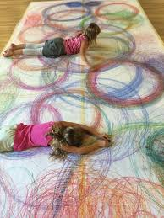

Nursery - Autumn 2