Forest Park Primary School Week beginning: Monday 6th July 2020
Nursery Home Learning Record

Weekly Checklist Try to tick off as many of these activities as you can each week as part of your home learning. Please send pictures of any activities you do to nursery@forestpark.org.uk  Reading-Aim for 10 minutes per day. Share a story together and talk about the pictures and characters in the story.  Mon⚪ Tues⚪ Wed⚪ Thurs⚪ Fri ⚪ Maths- Daily number recognition practice: -  Make cards with numbers 0-5 on.  Mix them up and lay them out on the floor. Ask your child to find a number. If your child can do this easily then add numbers up to 10 or 20  Mon⚪ Tues⚪ Wed⚪ Thurs⚪ Fri ⚪  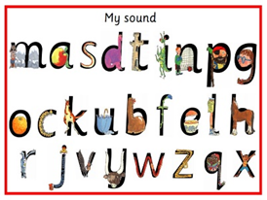  Sound recognition:  Make cards with the  Set 1 sounds on for your  child to look at. Ask your  child to find a sound.  Mon⚪ Tues⚪ Wed⚪ Thurs⚪ Fri ⚪ | Number  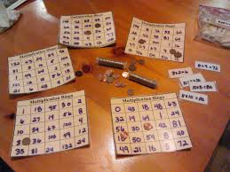  Make your own bingo cards 0-5 or 0-10 to play as a family.  Pattern  Have a go at making a pattern playing this game on a phone or tablet.  https://www.topmarks.co.uk/ordering-and-sequencing/shape-patterns  Send a picture of what you have done to  nursery@forestpark.org.uk  by the 1^{5th}July | Topic Review  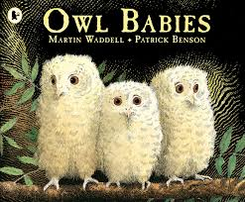  https://www.youtube.com/watch?v=TPQRiSTYFHo  Can you remember reading owl babies earlier in the year? Have a look at the story here.  Can you draw a picture of an owl?  What can you find out about owls? Where do they live? When do they sleep?  Please send photos of you completing this activity to Nursery email by Wednesday ^{15th} July

