

**Colours**

Our chosen stories…

‘The Colour Monster’

By Anna Llenas

‘Mixed’

By Arree Chung

‘The Smeds and the Smoos’

By Julia Donaldson

Can you name these

colours?

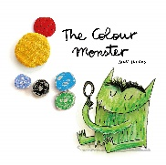

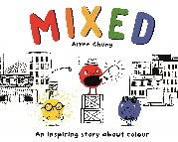

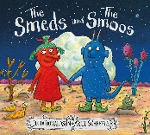

What will we be focussing on this half term?

• What do I want to be when I grow up?

• What are emotions and how do I feel?

• What do I look like?

• Who is special to me?

• What can I do with my body?

Can you identify the emotions?

We are looking at emotions and feelings. Can you identify the emotions and use them to describe your own feelings at home and school.

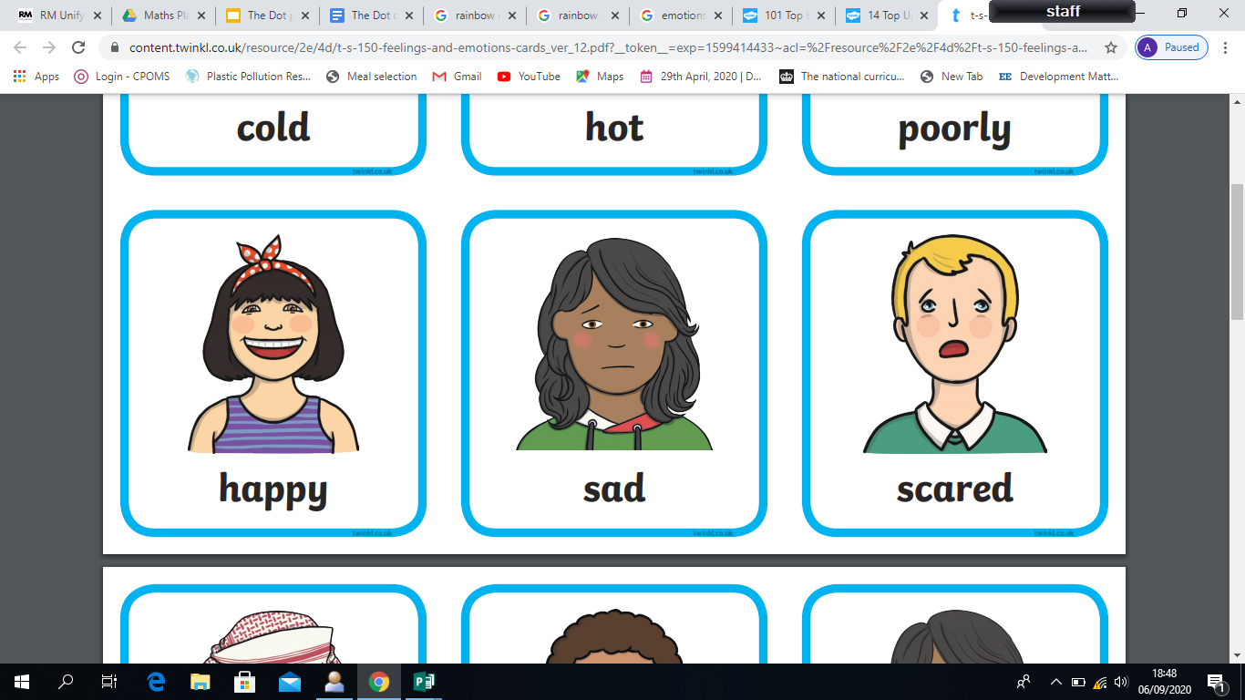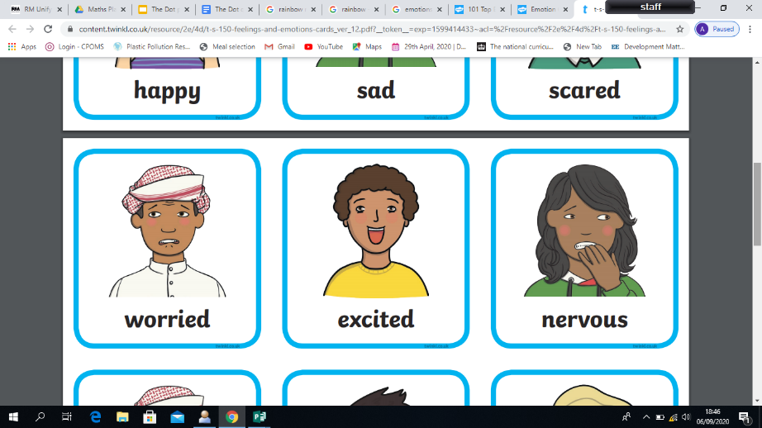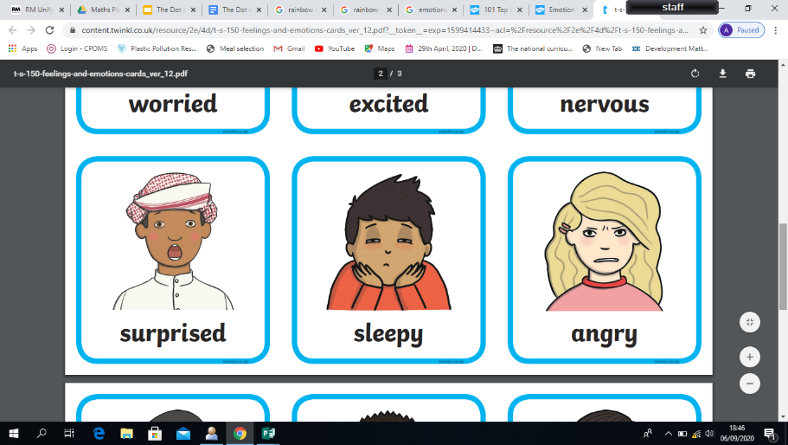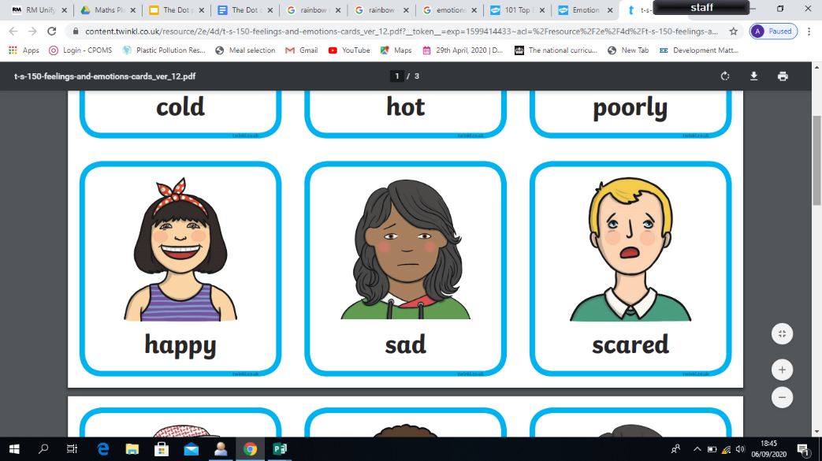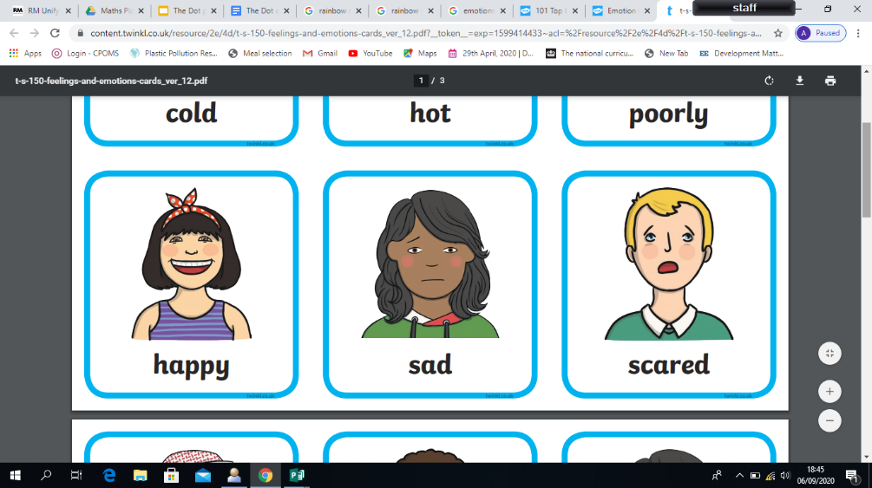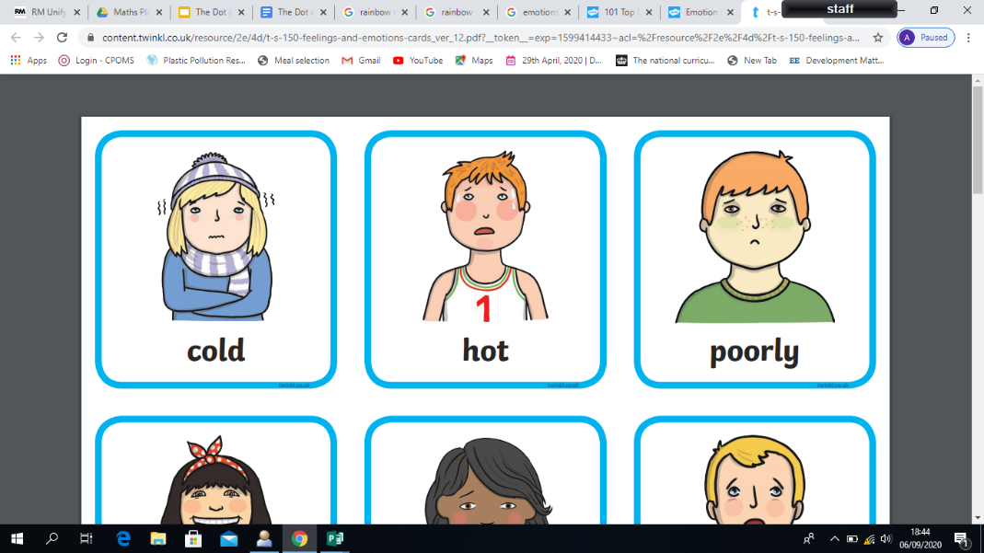

Can you name these characters? You might see them in your reading books!

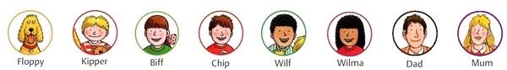

‘Colours’

|  |  |  |  |
| --- | --- | --- | --- |
| *Key words to learn and their meanings* | *Picture* | *Key words to learn and their meanings* | *Picture* |
| Family  The people you are related to and might live in the same house as. A feeling of belonging. |  | Home  The place where we live with our family. A place which makes us feel safe. | Image result for home is where the heart is |
| Friend  A person who is special to you and you like to play with. |  | Emotion  A strong feeling derived by your circumstance, environment mood and relationships with other. | Emotions and Feelings Cards |
| Job  What people do when they go to work. | Image result for occupations | Parts of the body  Face, Eyes, Ears, Nose, Mouth | Image result for face cartoon |
| Buttercup  A bright yellow cup shaped flower. The name of one of our  classes. | Image result for buttercups | Hair  Black, Brown, Ginger/red, Blonde, Grey | Image result for hair colours cartoon |
| Clover  A plant found in grass. The name of one of our classes. | Image result for clover | Aspiration  Hope or ambition of achieving something. | 3 Simple Things That Kill Dreams |
| Rules  A set of  instructions to keep us safe. | Image result for rules cartoon | Exercise  Jumping  Hopping  Running  Skipping  Walking | Image result for exercise cartoon |